Unit 7- Introduction to Website Development

Shes ahmed

level 2 IT

**INDEX**

|  |  |
| --- | --- |
|  |  |
|  |  |
|  |  |
|  |  |
|  |  |
|  |  |
|  |  |
|  |  |

**INTRODUCTION**

**(About website Development)**

**TASK 1**

1. Nike

Website link: <https://www.nike.ae/en/home>

Category: sales

Purpose:

* to showcase the shoes that are available
* to allow the customers to buy them
* they give information about their apps
* have details on how to contact them

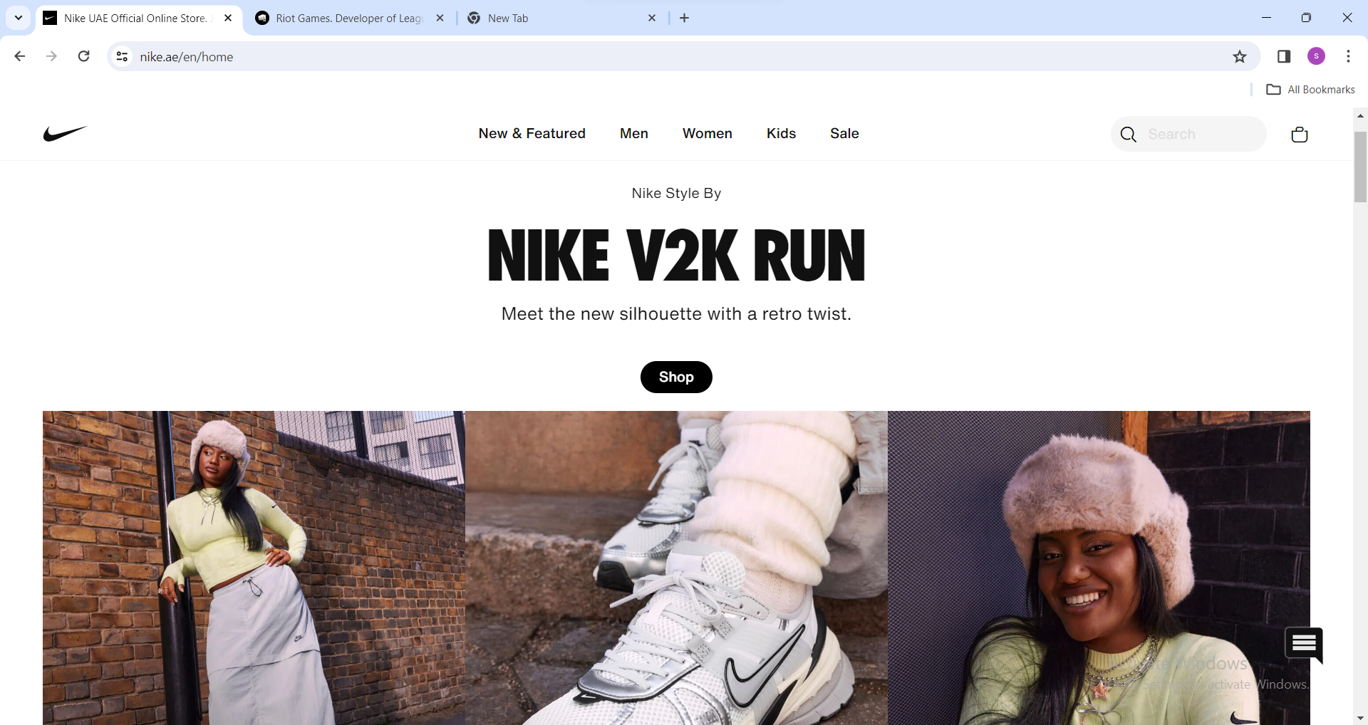

Components of the nike website:

* the shop button counts as a hot spot



* clicking on a product takes you to anoter page this is a hyperlink

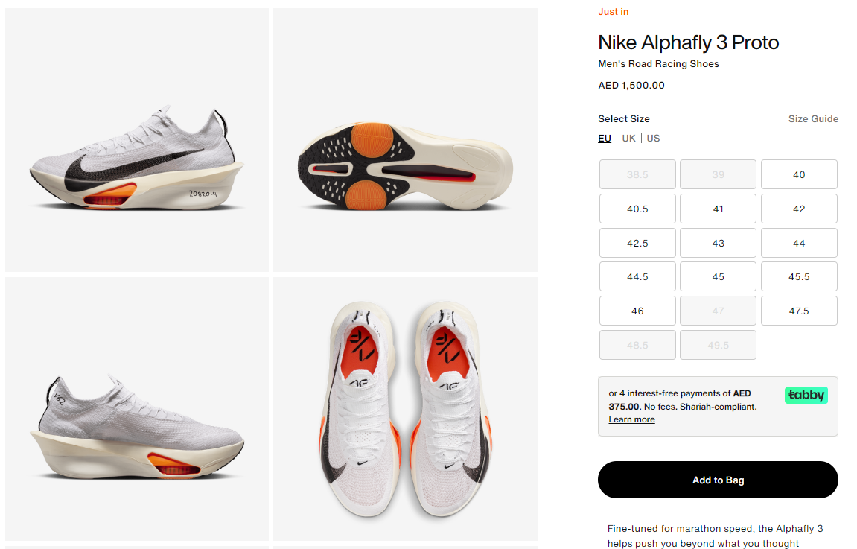

The logo:



Color combination for nike website:

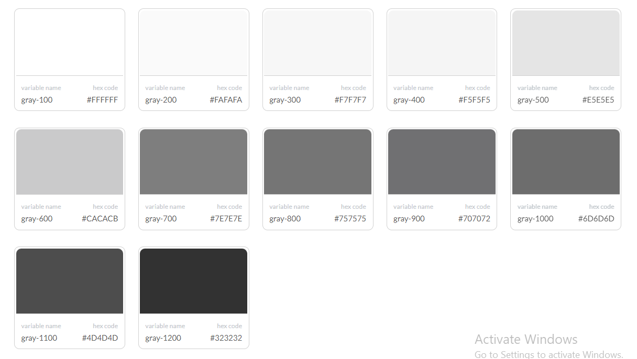

Font family for nike website: HelveticaNeue,Helvetica,Arial,sans-serif.

Aesthetic:

* the website mostly consists of the color white making it easier to digest.
* they have provided the users with trendy and relevant pictures to give them an idea of the product they purchase.

Accessibility:

* the Nike website has basic English which makes it easier for non-English speakers.
* it provides users with a good heading order.

Backend component for the Nike website:

* the search bar is a backend component because the products change with time and must get updated.
* The location is also a backend component as it gets updated depending on where you are
* The price changes as well depending on the economy, inflation etc.
* The images provided change with the trends as the products change.

Website grade:

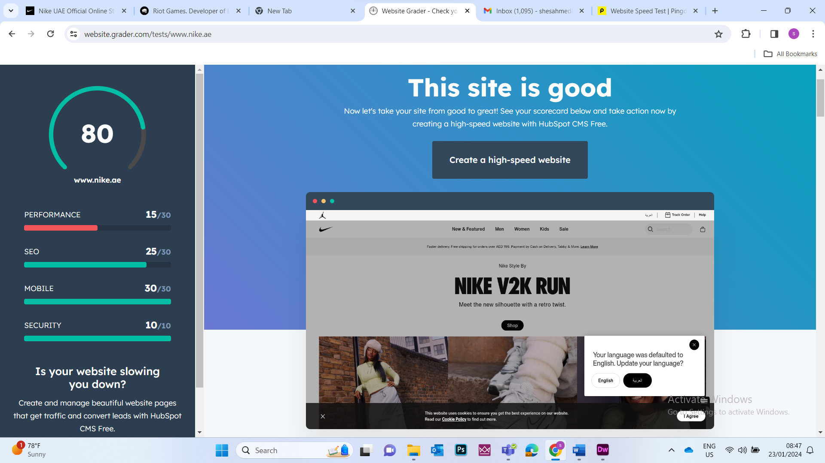

Website speed test:

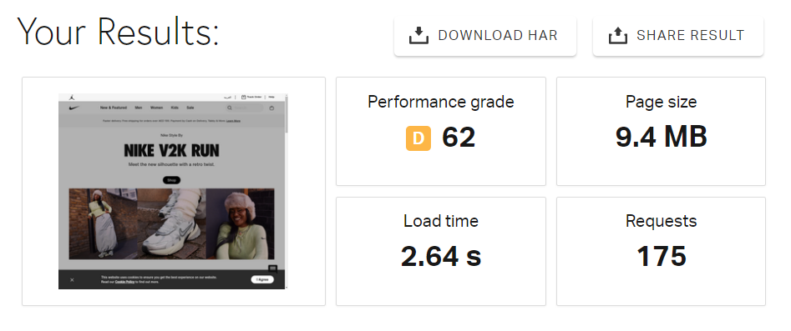

Phone compatbility:

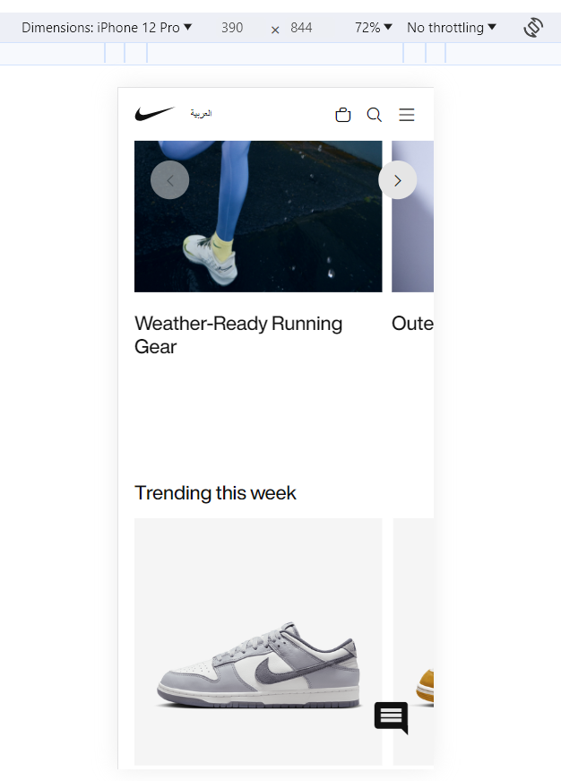

1. Riot games

Website link: <https://www.riotgames.com/en>

Category: information spreading website

Purpose:

* Gives news on any new collaborations
* Players can access new game updates and patch notes
* It hosts events and announcements and acts as a central hub for player support and communication

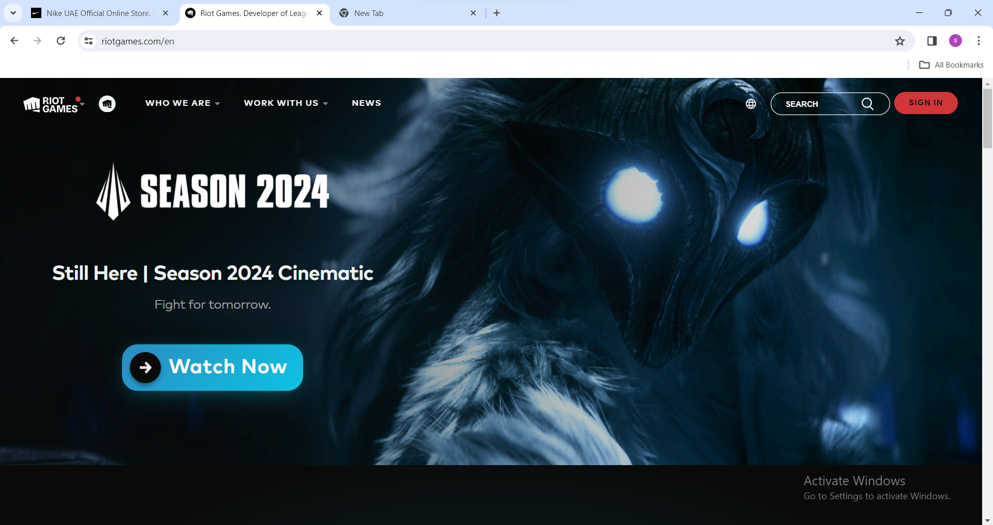

Components of the riot games website:

* it has hotspots which make it easier to access content as it is highlighted well



* it has hyperlinks

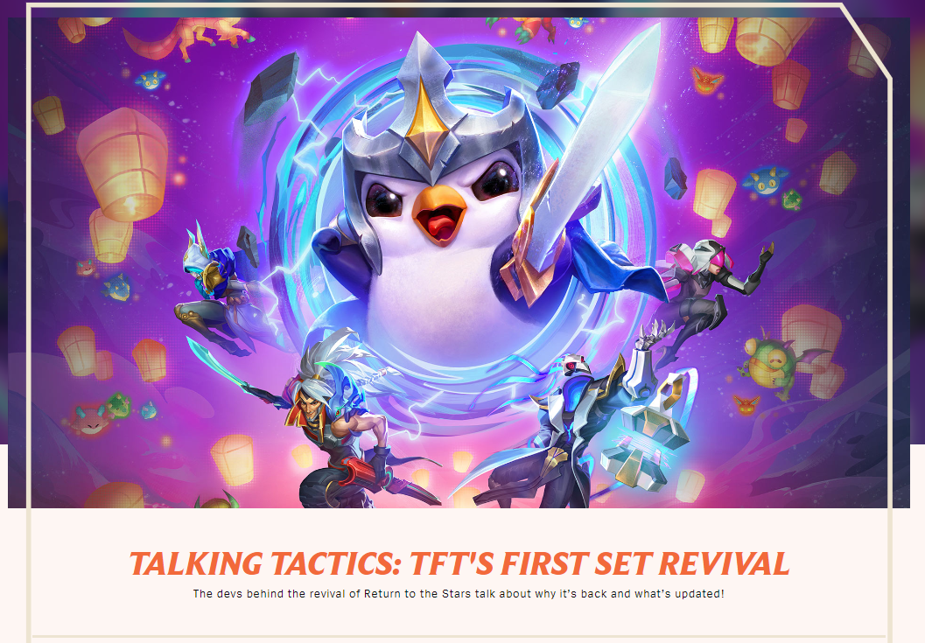

The logo:



Colour combination for riot website:

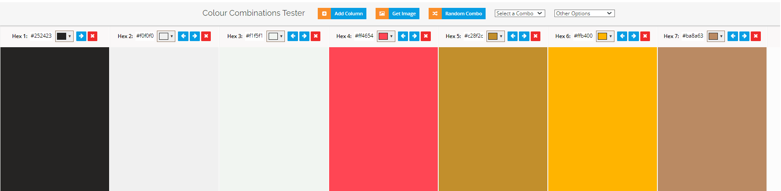

Font for riot website: 'Mark Pro',Arial,sans-serif

Aesthetic

* the use of the game characters to distinguish between different games making it easier to navigate through the website.
* The different categories have been sorted out with large white letters.
* The color combination for the website matches the aesthetic of the riot company/Logo.
* The front page has an iconic character from one of their most loved games to catch the attention of the user.

Accessibility:

* The riot website has a black background with white text which gives it a good contrast.
* It has an option to change language which gives people who don’t have the best knowledge of the English language an option to view he website with no drawbacks.
* It has large buttons to help the users point out certain things.
* it has a good heading structure which is in order allowing the user to distinguish between them.

Backend components of the riot website:

* the search bar which changes depending on what you’re searching for or if there is a new game.
* the news section of the website which is constantly getting updated depending on the things happening in the gaming space.
* The images of the games changing on when they get a new update and different characters get introduced

Website grader:

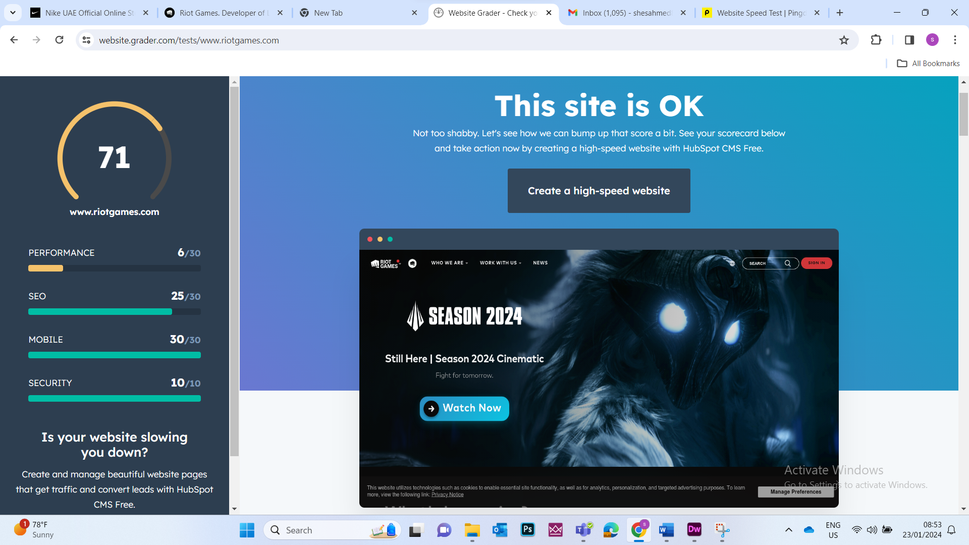

Website speed test:

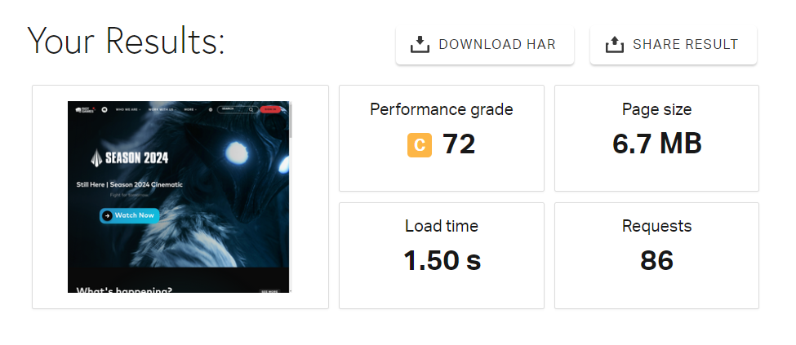

Phone compatability:

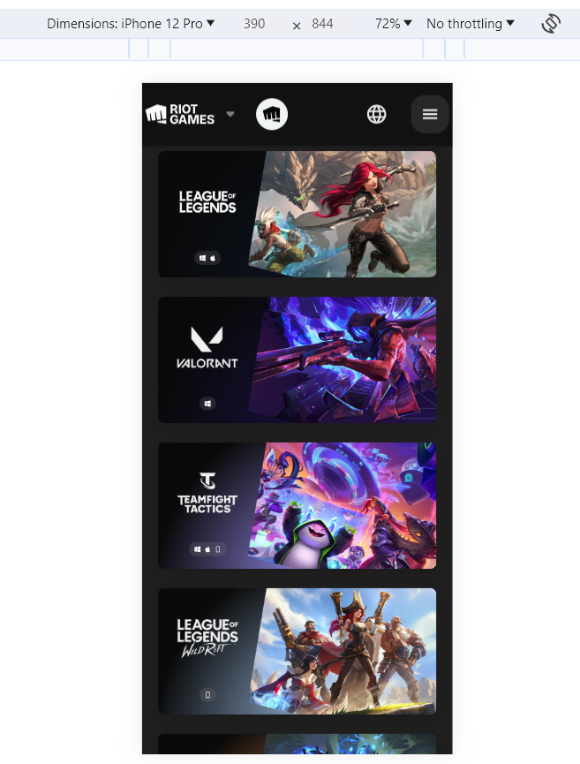

Answer for M1 Explain purposes and key components of different websites used by organisations.

Answer for D1 Evaluate the effectiveness of different websites used by organisations in relation to their purposes and key components.

**TASK 2**

The purpose of the website:

The website's goal is to draw attention to Evana's travelogues and her social media accounts for her trips to various locations.

The user requirements:

* The addition of her social medias at the end of the website so people can access more information.
* The addition of the places she has visited to the website
* The website should contain 5 pages at minimum 1 for each place mentioned.
* It should contain the following information: things to see, how to get there, when to go.
* It should contain an appropriate navigation system
* It should also have a consistent look across all pages
* Should contain a range of images, appropriate text and any other multimedia text.

**REFERENCES**